Rationale and policy for Reading at Lakeside School

Contents:

- Relevance of phonics- who, how, which resources? Reading schemes and relevant reading resources. Page 2.

- SCERTS (Social communication, emotional regulation, transactive support) Page 4.

- Keeping books and stories relevant and functional, plus how to tell a sensory story.
Page 7.

- Use of symbols- colour v black and white, size, key words, font etc. Page 9.

- Meshing individual needs with the curriculum expectations. Page 11.

Relevance of phonics
The crucial skill to teach is Reading for meaning the policy bellows details how we teach phonics while remembering that this is not an end in itself.
Policy for Teaching Phonics at Lakeside School

Phonics has to be taught and reinforced through activities that are relevant and tailored to each child’s individual needs and developmental level. For our pupils with Profound and multiple learning difficulties, those who are visually or hearing impaired and those pupils who are non-verbal and unable to make speech sounds, clearly learning phonics is not an option. Often reading in the traditional sense of the word is very difficult but all pupils at Lakeside are offered meaningful access to literacy. Some pupils will be able to learn to read conventionally and every effort is made to develop their literacy skills.

Our key approaches to teaching phonics

1. Promoting Listening skills
Developing children’s listening skills underpins our approach to phonics and learning to read. Listening skills are actively reinforced across the school curriculum. Each classroom environment supports listening skills through a consistent approach, for example:

- Being made aware of different sounds in their environment, for example, through sound walks
- Supporting the children to comment and copy different environmental sounds.
- Encouraging the children to discriminate between different sounds, for example, recording a sound walk, listening to it back and recognising the various sounds.
- Explore the musical instruments, available in class and in the playground.
- Repeat actions during an adult led activity and games.
- Explore instruments in child initiated play
- Experience and copy action songs and rhymes which involve sequencing simple actions, varying the pace of actions and recalling different sounds.

2. Letters and Sounds

Where they have been assessed to be relevant, letter sounds and phonic blends are reinforced orally and with visual support using strategies such as specialist computer programs and games linked to the alphabet, CVC words and the phonic blends.
We use reading schemes where they are motivating to the pupils but our approach is to train our teachers to understand the principles so that they can mesh the literacy to the interests and abilities of the pupil. You will find a lot of home-made literature which exemplifies the theories behind the teaching of phonics but is designed to really interest the pupil.

3. Consolidation

We recognise the importance of time, repetition and reinforcement when teaching phonics.

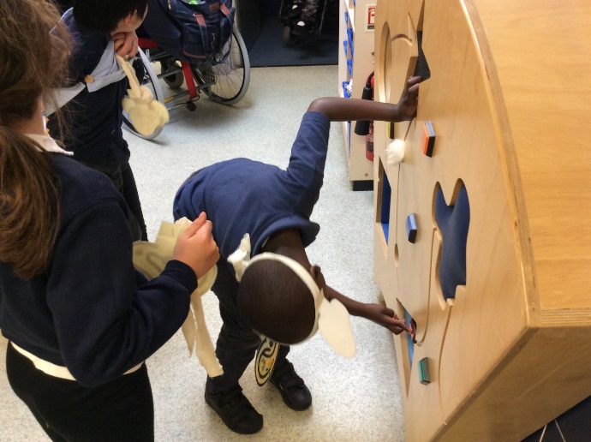
Primary one using their ‘listening’ ears to recognise sounds in the environment
Copying rhythms and exploring sound
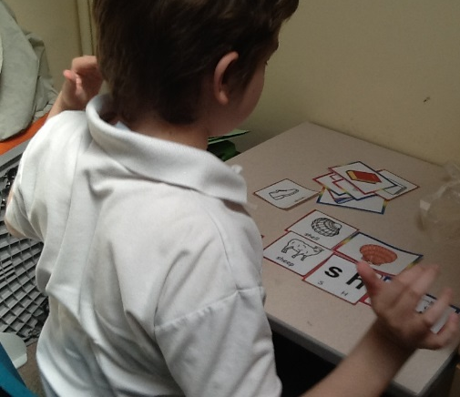
Pupils learn to categorise sounds and begin to recognise blends.

SCERTS support for speech and language structure (Prizant and Rubens et al 2012)
SCERTS (social communication, emotional regulation and transactive support) is a research based intervention for pupils with autism. The approach is developmental and uses growing knowledge regarding neuro science as it relates to autism in order to support learning to live in a calm and functional way. Our teachers are all shown by our team of in house trainers to use this approach effectively.
Social partner
Most of our pupils will fall within what is known as the ‘social partner’ stage of communication development. This is the stage during which children learn to access other people. We support them to learn to play and to make simple requests for what they want. The very first attempts at communication are honoured and promoted, for example, we may place favoured objects in see-through jars and give these objects to the children when they make an attempt to touch the jar or give it to us. This is the very beginning of reading where children are learning to understand very rudimentary symbols such as smaller objects that represent the favoured objects they want to play with.

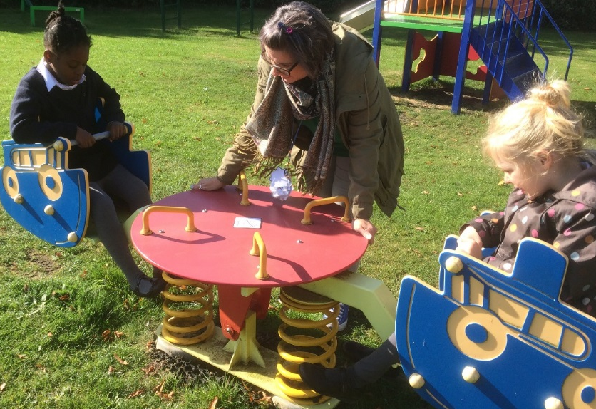
Adult waits for pupils to ask for a push using the symbol

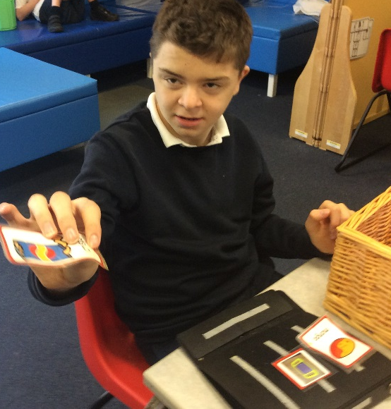 Pupil highly motivated by food spontaneously communicates that he wants some crisps using a symbol from a choice of other symbols.

SCERTS, Language Partner
Some of our pupils progress to the language partner stage where they begin to be able to use speech in a functional way to ask for what they want, describe events or to tell us how they feel. During this stage we support the growing architecture of language for them by structuring their learning into coloured framed symbols. The colours apply to a code which is agreed by the speech therapists:
Orange shapes tell us who
Yellow shapes tell us what they are doing
Green shapes tell us what/Object
Blue shapes tell us where
Pink shapes tell us who TO
Brown shapes tell us WHEN
Black shapes tell us how
A summary of colour coding

- A highly effective visual way of coding the information in words and sentences. It helps children understand how the meanings of words are linked in sentences.
- Question words are used to link to this meaning. Each question word is designated a colour or shape.
- Originally used to help children understand how the meaning of words are linked in sentences. This then helped them make correct sentences when talking.
- The system can be used to support:
- Learning and recalling vocabulary
- Learning and linking new facts
- Understanding question words
- Ordering ideas to make a narrative
- Understanding written text

Benefits of colour coding
- Works well with children with very limited language. Allows them to participate in group activities.
- Provides a simple structure for children with disorganised language, who often progress to longer narratives quite quickly.
- Encourages children who have motor difficulties with speech to participate as the pictures support their speech.
- It can be tailored to different levels within a group activity by adding conjunctions / more complex sentence templates.

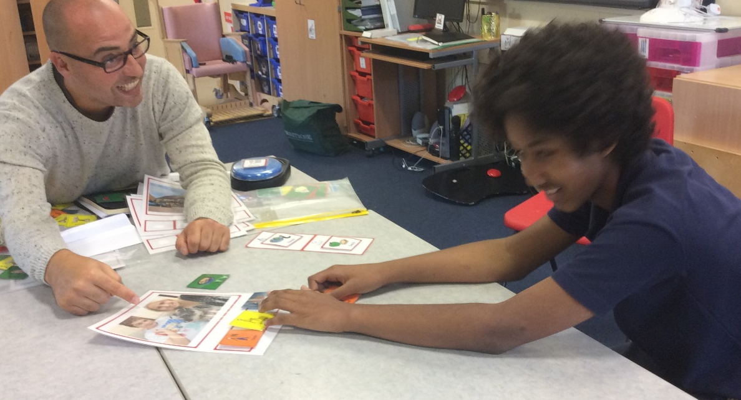
This student has learned to place symbols together to make a meaningful sentence using the colour-coded method.

Keeping books and stories relevant and functional
Listening to a story from a book should never be a passive activity for developmentally young children. It is important to develop skills linked to anticipation, sequencing events, imagination, meaning, and expanding word use- adjectives, pronouns and adverbs.
Books should be as relevant as possible to the experience of the listening students – accompanied by objects of reference for each significant event depicted in the book. These objects of reference should clearly represent the objects or events.
Stories should be as age appropriate as possible- this means that for the older students you may need to be imaginative with DVDs, stories about themselves and non-fiction such as recipe books. It must always be fun- it is worth researching likes and dislikes before you start a book as students may not enjoy it. Sometimes making your own resources/ stories may be the best way forward.
Repeat and build up the story week on week. Put in markers that use all the senses throughout the story.
Making books for individual students including photos of their family, pets, friends and favourite places or activities is a great way to motivate reluctant readers. Students begin to see print as a symbol for something if it is entirely meaningful and special to them. We are equipping pupils to read for their own purposes and interests, for example, they may love cars and so need to find their way around car magazines and websites.
It is a question of knowing the developmental level they are at and then designing the book accordingly. A pupil who is at a one word level will have photos of one person per page or one object per page. Another pupil may need action shots so that they can learn to read common verbs etc. This has a dual purpose: It is very supportive of speech learning especially in pupils with autism and of course it supports reading for meaning and practicing phonics.

How to tell a sensory story
Think about each sense
Use a story that the children like and adapt and introduce sensory objects to support the story
Collect resources that depict the story but more importantly offer a sensory experience
Objects need to be representational and as close to the real thing as possible.
The skills you are promoting are:
- Recognition
- Anticipation
- Predicting a sequence
- Naming objects and verbs
Differentiate your resources so that pupils who can read symbols can select the symbol for each object or event in the story and pupils who are at more of a sensory level can have time with the resources and learn to anticipate each activity within the story.

Pupils should have the opportunity to look at a big book….

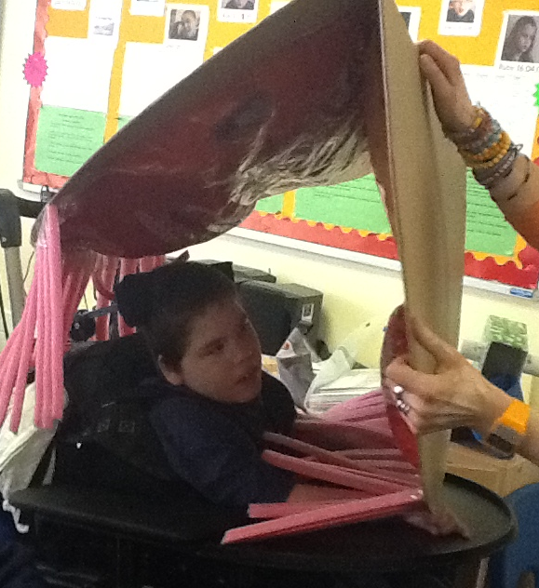 ……and to experience and interact with the props for the story.

This student is enjoying looking at a book made especially for her comprising of pictures and sentences about her classmates.
Use of symbols- colour v black and white, size, key words, font etc
Please see also our “communication continuum “
Stage 1: Objects of reference
This is the first stage in any kind of symbolic representation. Object cues are used to signify different lessons or places around school.
Objects are used in stories but remember if you have never seen or had experience of a zebra, you will not know what a fluffy toy zebra is. It will just be a stripy soft thing. Be very careful how you select stories for children with severe learning difficulties and limited language and experience..
Children need lots of experience with real objects before you can expect them to understand a picture of a real object.
Stage 2: Photos
Provide photos of places and people around school for pupil to go to that place or person and match the photo.
Provide games with photos to match to real objects- this should be extended so that the photo stays the same but the real object while in that category is not exactly the same as the photo. For example, a lot of different types of cup can be matched to a photograph of one cup.
Stage 3: Symbols
It is best to use symbols from the start when teaching generic concepts such as ‘toilet’, ‘drink’ ‘dinner’, ‘car’ etc.
Use photos where the object is special to the child, a favourite toy or activity.
It is best to use black and white symbols for these generic concepts as they are so common that pupils may focus on the colour of the symbol rather than the object the symbol denotes.
Lots of games can be made for matching photos to symbols – again make sure that pupils have lots of practice at noticing categories and the same materials are not presented over and over again.
Please be aware that using mat laminate sheets is preferable to shiny laminate sheets for pupils with visual impairment and sometimes pupils with autism who are only interested in the shiny nature of the symbol.
Stage 4: Words and sentences
Start to match the written word to the symbol. The symbol can be larger at first and gradually reduced as the word becomes more familiar.

This pupil can complete a cooking task independently through structured use of symbols to show her the steps.

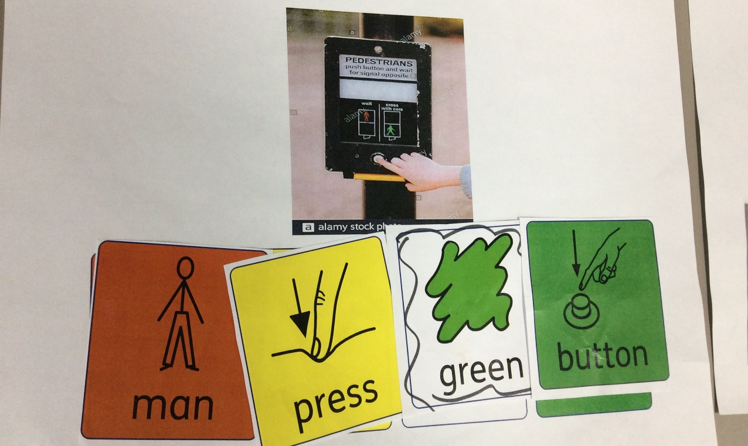
Sentence structure easily seen with the colour prompt
Meshing individual needs with the curriculum expectations
In other words: What do our pupils need in order to lead fulfilling daily lives and be able to make sense of the world in which they live?
Social signs and vocabulary:
For example can they find the correct gender toilet when they are out?
Do they know where the exit is?
Can they find the supermarket they want, where to pay and the products they want on their shopping trip?
Signs on bottles, cleaning products and toiletries are important to know for safety reasons.
This all starts when they are small- can they find their way around school?
Can they point to the picture of what they want in McDonalds?
Very few SLD pupils will eventually be able to read for pleasure. This does not mean that they will not enjoy looking at a magazine or finding things on the internet or shopping etc where their social sight and basic reading skills will come in useful. Teachers should always remember to provide individually tailored magazines, books, reading material as pupils will only be motivated to pick it up and look at it if it is interesting to them.
It is essential to go out into the community with pupils of all ages. It is here that they will learn to use their reading skills functionally. Teachers can plan a whole series of lessons or activities based upon the print that pupils will need to read when they go to a café or to the shops.
Life skills are most important. If we teach these as a priority our pupils will be able to access and enjoy everyday life as independently as possible.

